

**ZEZA STORIES**

**SUBMITTED BY**

ZIKRA ZAHID (2021-BSE-035)

EYMAN AMEER (2021-BSE-010)

**SUBMITTED TO:**

DR BUSHRA BASHIR

**COURSE TITLE**

ANDROID APP DEVELOPMENT

**SEMESTER/SECTION**

6-A

**SUBMISSION DATE**

25-06-2024

Contents

Introduction 2

Tools For UI 2

Tool For UX 2

Screens Designs 3

Code 4

# Introduction

We developed an app named **ZEZA Stories**, which consists of various stories for kids.

1. **User Sign-Up**: Users are required to sign up when they first use the app. The sign-up process includes collecting the user's location.
2. **Story List**: After signing up, a list of available stories is presented, accompanied by an instrumental song in the background.
3. **Story Selection**: When the user selects a story from the list, the story is displayed on the screen. Users also have the option to listen to the story being narrated.
4. **Adapter View**: We have implemented an Adapter View in our database, which converts the list view screen into an adapter screen, enhancing the display and functionality of the story list.

# Tools For UI

* We designed screens on **Canva** and **Figma**
* We designed Logo on **Canva.**

# Tool For UX

* We used **Android Studio**.

# Screens Designs

1. Main Screen

1. Login in / Sign Up Screen

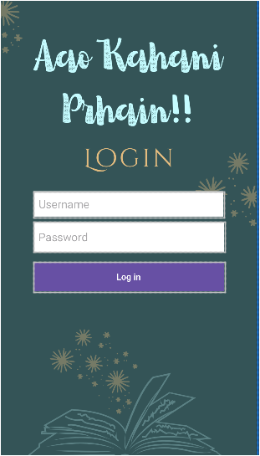 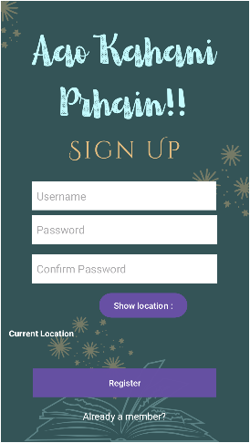

1. List View Screen (.xml view) Adapter Screen (App View)

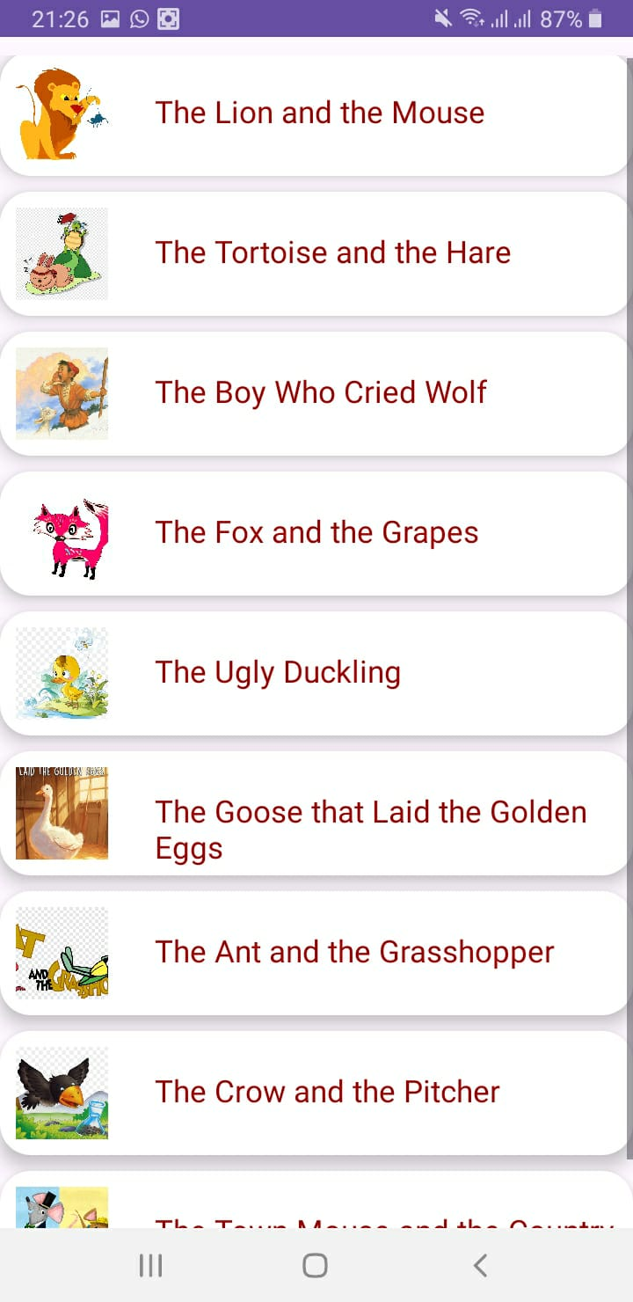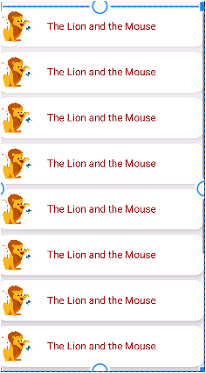

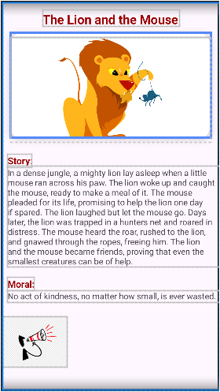  
4. Story Screen

# Code

1. Story Screen Code

package com.example.project;  
  
import androidx.appcompat.app.AppCompatActivity;  
import android.content.Intent;  
import android.os.Bundle;  
import android.speech.tts.TextToSpeech;  
import android.view.View;  
  
import com.example.project.databinding.ActivityItemdetailBinding;  
  
import java.util.Locale;  
  
public class itemdetail extends AppCompatActivity {  
 private TextToSpeech textToSpeech;  
 private ActivityItemdetailBinding binding;  
 private boolean isPaused = false;  
 private int currentIndex = 0;  
 private String storyText = "";  
 private String moralText = "";  
  
 @Override  
 protected void onCreate(Bundle savedInstanceState) {  
 super.onCreate(savedInstanceState);  
 binding = ActivityItemdetailBinding.*inflate*(getLayoutInflater());  
 setContentView(binding.getRoot());  
  
 // Handle the incoming intent  
 Intent intent = getIntent();  
 if (intent != null) {  
 String title = intent.getStringExtra("title");  
 int moralResId = intent.getIntExtra("moral", R.string.*lionMouseMoral*);  
 int storyResId = intent.getIntExtra("story", R.string.*lionMouseStory*);  
 int image = intent.getIntExtra("image", R.drawable.*lion*);  
  
 storyText = getString(storyResId);  
 moralText = getString(moralResId);  
  
 binding.detailName.setText(title);  
 binding.detailStory.setText(storyText);  
 binding.detailMoral.setText(moralText);  
 binding.detailImage.setImageResource(image);  
 }  
  
 // Initialize TextToSpeech  
 textToSpeech = new TextToSpeech(this, new TextToSpeech.OnInitListener() {  
 @Override  
 public void onInit(int status) {  
 if (status == TextToSpeech.*SUCCESS*) {  
 // Set language  
 int result = textToSpeech.setLanguage(Locale.*ENGLISH*);  
 if (result == TextToSpeech.*LANG_MISSING_DATA* || result == TextToSpeech.*LANG_NOT_SUPPORTED*) {  
 // Handle the error if the language is not supported  
 } else {  
 // Enable the button once the TTS engine is initialized  
 binding.button.setEnabled(true);  
 }  
 } else {  
 // Initialization failed  
 }  
 }  
 });  
  
 // Set up the button to trigger text-to-speech  
 binding.button.setOnClickListener(new View.OnClickListener() {  
 @Override  
 public void onClick(View v) {  
 if (isPaused) {  
 stopSpeaking();  
 } else {  
 startSpeaking();  
 }  
 }  
 });  
 }  
  
 private void startSpeaking() {  
 isPaused = false;  
 textToSpeech.speak(storyText.substring(currentIndex) + ". Moral: " + moralText, TextToSpeech.*QUEUE_FLUSH*, null, null);  
 }  
  
 private void stopSpeaking() {  
 isPaused = true;  
 super.onDestroy();  
 //startSpeaking();  
 }  
  
 @Override  
 public void onDestroy() {  
 // Shutdown TextToSpeech to release resources  
 if (textToSpeech != null) {  
 textToSpeech.stop();  
 textToSpeech.shutdown();  
 }  
 super.onDestroy();  
 }  
}

1. List View Screen Code

package com.example.project;  
  
import androidx.appcompat.app.AppCompatActivity;  
import android.content.Intent;  
import android.media.MediaPlayer;  
import android.os.Bundle;  
import android.view.View;  
import android.widget.AdapterView;  
import android.widget.ListView;  
  
import com.example.project.databinding.ActivityMain3Binding;  
  
import java.util.ArrayList;  
  
public class MainActivity3 extends AppCompatActivity {  
  
 ActivityMain3Binding binding;  
 ListAdapter listAdapter;  
 ArrayList<ListData> dataArrayList = new ArrayList<>();  
 MediaPlayer mediaPlayer;  
  
 @Override  
 protected void onCreate(Bundle savedInstanceState) {  
 super.onCreate(savedInstanceState);  
 binding = ActivityMain3Binding.*inflate*(getLayoutInflater());  
 setContentView(binding.getRoot());  
  
 // Initialize and start the background music  
 mediaPlayer = MediaPlayer.*create*(this, R.raw.*music*);  
 mediaPlayer.setLooping(true); // Loop the music  
 mediaPlayer.start();  
  
 // Define arrays for stories  
 int[] imageList = {  
 R.drawable.*lion*,  
 R.drawable.*tortise*,  
 R.drawable.*boy*,  
 R.drawable.*focxy*,  
 R.drawable.*ducck*,  
 R.drawable.*golden*,  
 R.drawable.*ant*,  
 R.drawable.*croww*,  
 R.drawable.*mouse* };  
  
 String[] nameList = {  
 getString(R.string.*lionMouseTitle*),  
 getString(R.string.*tortoiseHareTitle*),  
 getString(R.string.*boyWolfTitle*),  
 getString(R.string.*foxGrapesTitle*),  
 getString(R.string.*uglyDucklingTitle*),  
 getString(R.string.*TheGoosethatLaidtheGoldenEggs*),  
 getString(R.string.*antGrasshopperTitle*),  
 getString(R.string.*crowPitcherTitle*),  
 getString(R.string.*townCountryMouseTitle*)  
 };  
  
 int[] storyList = {  
 R.string.*lionMouseStory*,  
 R.string.*tortoiseHareStory*,  
 R.string.*boyWolfStory*,  
 R.string.*foxGrapesStory*,  
 R.string.*uglyDucklingStory*,  
 R.string.*TheGoosethatLaidtheGoldenEggsStory*,  
 R.string.*antGrasshopperStory*,  
 R.string.*crowPitcherStory*,  
 R.string.*townCountryMouseStory* };  
  
 int[] moralList = {  
 R.string.*lionMouseMoral*,  
 R.string.*tortoiseHareMoral*,  
 R.string.*boyWolfMoral*,  
 R.string.*foxGrapesMoral*,  
 R.string.*uglyDucklingMoral*,  
 R.string.*TheGoosethatLaidtheGoldenEggsMoral*,  
 R.string.*antGrasshopperMoral*,  
 R.string.*crowPitcherMoral*,  
 R.string.*townCountryMouseMoral* };  
  
 // Populate dataArrayList with ListData objects  
 for (int i = 0; i < nameList.length; i++) {  
 ListData listData = new ListData(nameList[i], storyList[i], moralList[i], imageList[i]);  
 dataArrayList.add(listData);  
 }  
  
 // Set up the ListView with the ListAdapter  
 listAdapter = new ListAdapter(MainActivity3.this, dataArrayList);  
 binding.listview.setAdapter(listAdapter);  
  
 // Handle item click listener  
 binding.listview.setOnItemClickListener(new AdapterView.OnItemClickListener() {  
 @Override  
 public void onItemClick(AdapterView<?> adapterView, View view, int i, long l) {  
 ListData selectedData = dataArrayList.get(i);  
  
 Intent intent = new Intent(MainActivity3.this, itemdetail.class);  
 intent.putExtra("title", selectedData.name);  
 intent.putExtra("moral", selectedData.moral);  
 intent.putExtra("story", selectedData.story); // Assuming story is a string resource ID  
 intent.putExtra("image", selectedData.image);  
 // intent.putExtra("voice", selectedData.button);  
 startActivity(intent);  
 }  
 });  
 }  
  
 @Override  
 protected void onPause() {  
 super.onPause();  
 // Pause the MediaPlayer when the activity is paused  
 if (mediaPlayer != null && mediaPlayer.isPlaying()) {  
 mediaPlayer.pause();  
 }  
 }  
  
 @Override  
 protected void onResume() {  
 super.onResume();  
 // Resume the MediaPlayer when the activity is resumed  
 if (mediaPlayer != null && !mediaPlayer.isPlaying()) {  
 mediaPlayer.start();  
 }  
 }  
  
 @Override  
 protected void onDestroy() {  
 super.onDestroy();  
 // Release the MediaPlayer resources  
 if (mediaPlayer != null) {  
 mediaPlayer.release();  
 mediaPlayer = null;  
 }  
 }  
}

1. Adapter Screen Code

package com.example.project;  
  
import android.content.Context;  
import android.view.LayoutInflater;  
import android.view.View;  
import android.view.ViewGroup;  
import android.widget.ArrayAdapter;  
import android.widget.ImageView;  
import android.widget.TextView;  
  
import java.util.ArrayList;  
  
import androidx.annotation.NonNull;  
import androidx.annotation.Nullable;  
  
public class ListAdapter extends ArrayAdapter<ListData> {  
  
 public ListAdapter(@NonNull Context context, ArrayList<ListData> dataArrayList) {  
 super(context, R.layout.*activity_mainscreen*, dataArrayList);  
 }  
  
 @NonNull  
 @Override  
 public View getView(int position, @Nullable View view, @NonNull ViewGroup parent) {  
 ListData listData = getItem(position);  
  
 if (view == null) {  
 view = LayoutInflater.*from*(getContext()).inflate(R.layout.*activity_mainscreen*, parent, false);  
 }  
  
 TextView listname = view.findViewById(R.id.*listName*);  
  
 ImageView listImage = view.findViewById(R.id.*listImage*);  
  
 listname.setText(listData.name);  
  
 listImage.setImageResource(listData.image);  
  
 return view;  
 }  
}

1. Database Code

package com.example.project;  
  
import android.content.ContentValues;  
import android.content.Context;  
import android.database.Cursor;  
import android.database.sqlite.SQLiteDatabase;  
import android.database.sqlite.SQLiteOpenHelper;  
  
import androidx.annotation.Nullable;  
  
public class DBhelper extends SQLiteOpenHelper {  
 public static final String *DBName*="register.db";  
  
 public DBhelper(@Nullable Context context) {  
 super(context, *DBName*, null, 1);  
 }  
  
 @Override  
 public void onCreate(SQLiteDatabase db) {  
db.execSQL("create table users(username Text primary key, password Text)");  
 }  
  
 @Override  
 public void onUpgrade(SQLiteDatabase db, int i, int i1) {  
 db.execSQL("drop table if exists users");  
 }  
 public boolean insertData(String username, String password) {  
 SQLiteDatabase myDB = this.getWritableDatabase();  
 ContentValues contentValues = new ContentValues();  
 contentValues.put("username", username);  
 contentValues.put("password", password);  
 long result= myDB.insert("users", null,contentValues);  
 if(result==-1)return false;  
 else return true;  
 }  
 public boolean checkUsername(String username){  
 SQLiteDatabase myDB=this.getWritableDatabase();  
 Cursor cursor=myDB.rawQuery("select * from users where username=?",new String[]{username});  
 if (cursor.getCount()>0)  
 return true;  
 else return false;  
 }  
 public boolean checkUser(String username, String pwd) {  
 SQLiteDatabase myDB = this.getWritableDatabase();  
 Cursor cursor = myDB.rawQuery("SELECT * FROM users WHERE username = ? AND password = ?", new String[]{username, pwd});  
 if (cursor.getCount() > 0)  
 return true;  
 else  
 return false;  
 }  
  
}

**References:**

<https://www.canva.com/design/DAGJA8au1Kg/2yqBwRyboCiTysKkmPqbGg/view?utm_content=DAGJA8au1Kg&utm_campaign=designshare&utm_medium=link&utm_source=editor>

<https://www.figma.com/design/mZYuBoddq0L9gj5kUeQMC8/Sanity-Sketching-Kit-(Community)?node-id=317-2167&t=PgfnwTFS8U10rc0t-1>  
  
<https://www.canva.com/design/DAGJBVU0xAk/anB6M7jwJbia1HJ72VBazw/view?utm_content=DAGJBVU0xAk&utm_campaign=designshare&utm_medium=link&utm_source=editor>